**Responsive web page**

**Title:** Responsive Web Page

**Overview**:

ODYSSEY is a website dedicated to space exploration and enthusiasts. It offers a variety of resources, including news articles, educational resources, and a community forum. The website is designed to be easy to use and navigate, and it provides a wealth of information about space science and technology.

* **Navbar**:
* The navbar is located at the top of the page and includes the ODYSSEY logo, a search bar, and a navigation menu.
* The navigation menu includes links to the following pages: Home, News, Articles, Resources, Forum, and About Us.
* The navbar is designed to be easy to use and navigate, and it helps users find the information they are looking for quickly and easily.
* **Image**:
* The image is located at the top of the page and takes up the full width of the page.
* The image is a high-quality photograph of a galaxy.
* The image is used to capture the attention of users and to create a sense of awe and wonder.
* 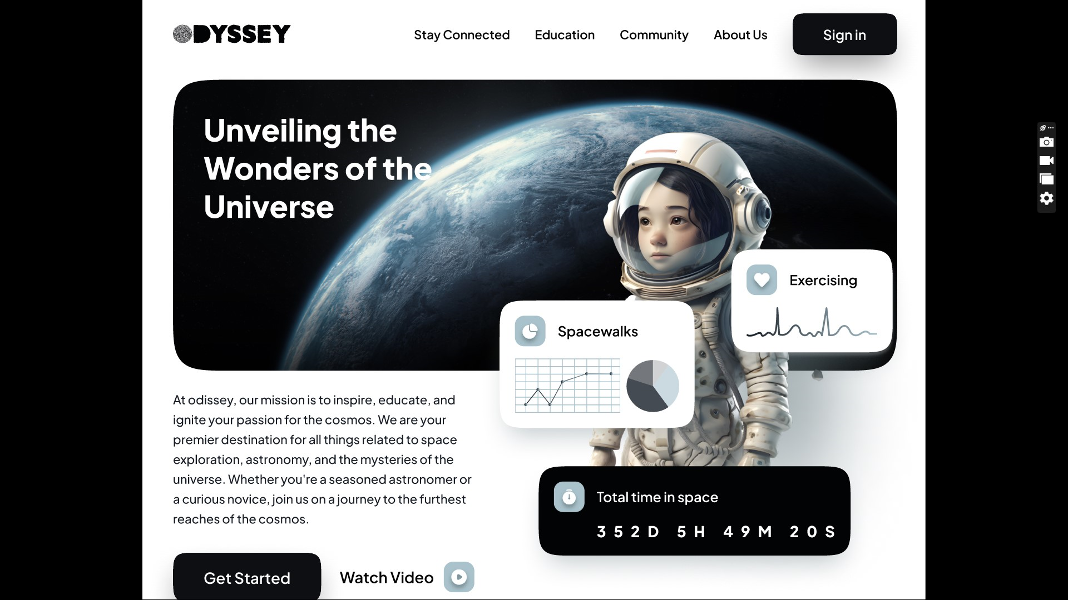
* **Cards** :
* The cards are located in the middle of the page and are used to display news articles.
* Each card includes a headline, a brief summary of the article, and a link to the full article.
* The cards are designed to be visually appealing and to make it easy for users to scan the news headlines.

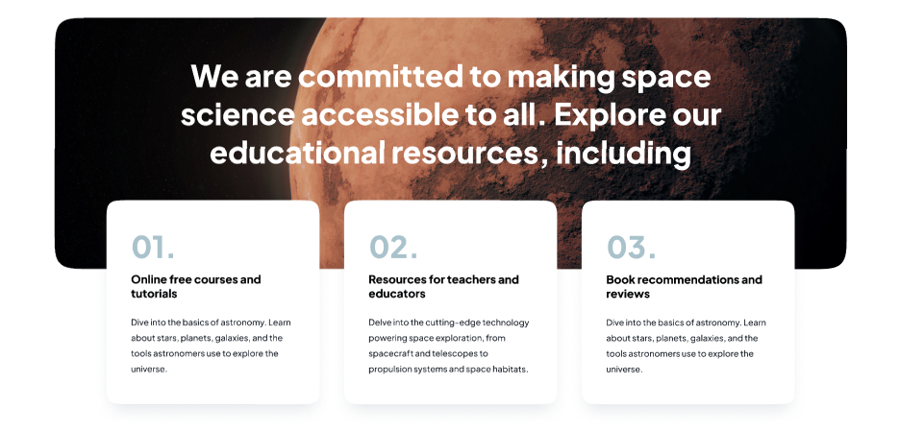

* **Font & Content :**
* The website uses a sans-serif font that is easy to read on screens of all sizes.
* The font size is large enough to be easy to read, but not so large that it makes the page look cluttered.
* The content is written in a clear and concise style that is easy to understand.

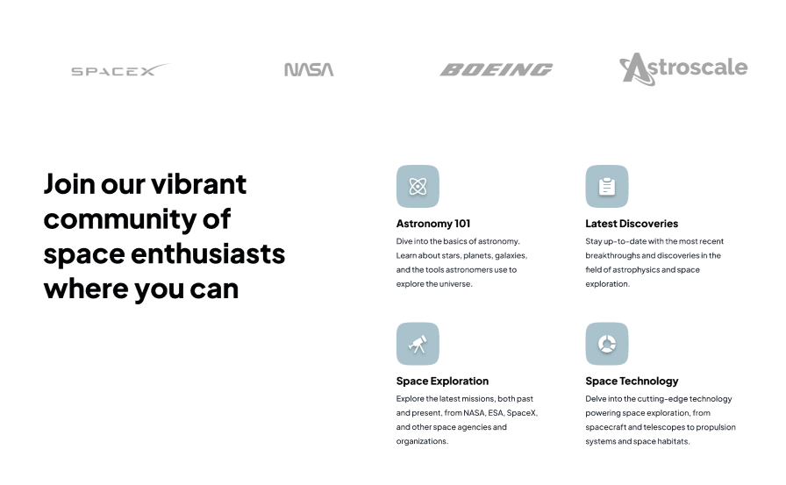

* **Community & Footer:**
* The community section is located at the bottom of the page and includes a forum where users can discuss space exploration and space technology.
* The forum is divided into different categories, such as astronomy, astrophysics, and space exploration.
* The footer includes links to the ODYSSEY social media pages, as well as a copyright notice and a privacy policy.

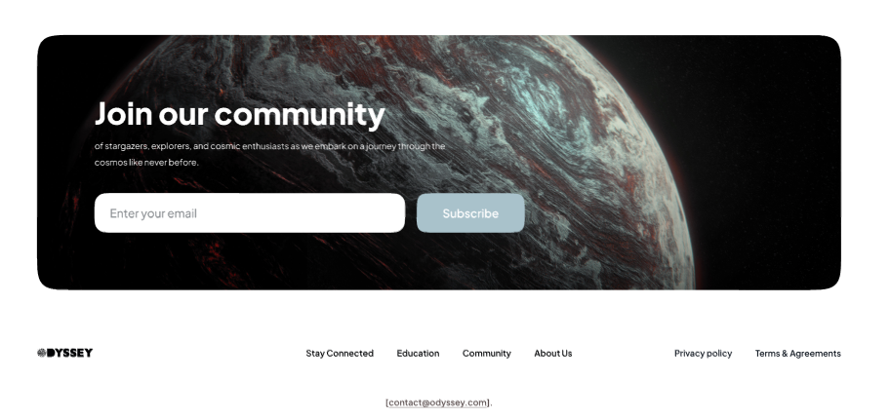

**Responsive**: clear responsive for various screen modes.

Everything is sastisfied as per the task requirements

**Visualization** :

* The website uses a clean and modern design with a focus on white space and large, high-quality images.
* The layout is easy to follow and navigate, with a consistent header, navigation menu, and footer.
* The use of color is minimal and tasteful, with a focus on blue and white to create a sense of calm and professionalism.

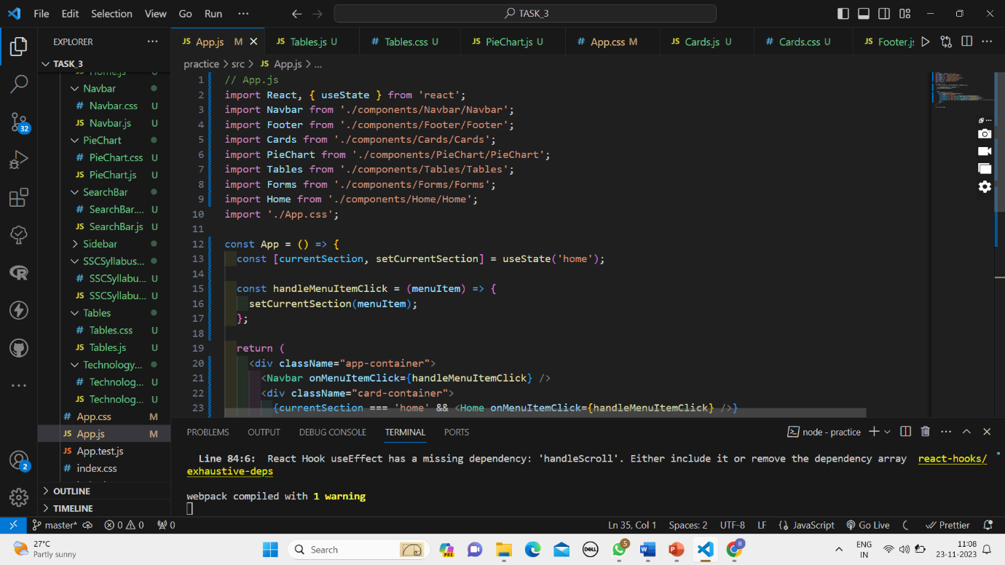

**Code Review:**

**1.Code Organization:**

* Code is well-organized into separate files and functions. This makes it easy to read and maintain.

**2. Variable and function names:**

* Variable and function names are descriptive and meaningful. This makes it easy to understand what your code is doing.

**3. Functionality**

* The website is easy to use and navigate, with a clear hierarchy of information.
* The search bar allows users to quickly find the information they are looking for.
* The cards provide a quick and easy way to scan the news headlines.
* The community forum allows users to connect with other space enthusiasts and share their knowledge.
* **Conclusion:**

**.** The ODYSSEY website appears to be a well-designed and informative resource for space enthusiasts of all ages and backgrounds. The website features a clean and modern design, easy-to-use navigation, and a wealth of content about space science and technology. The community forum provides a space for users to connect with other space enthusiasts and share their knowledge. Overall, the ODYSSEY website is an effective and engaging resource for anyone interested in learning more about space exploration.